**+Vivekananda Education Society’s Institute of Technology**

**Department of Computer Engineering**



**EMPLOYEE MANAGEMENT SYSTEM**

**(DDB MINI PROJECT)**

**____________________________________**

**SUBJECT**

**DISTRIBUTED DATABASE SYSTEM**

**PROJECT BY**

**Sanket Mhatre(40)**

**Shripad Laddha(38)**

**Vinay Niar(47)**

**D12B**

**PROBLEM STATEMENT -**

We Know that in any technical education office , the manager of office used to spare alot of time even after the normal office hours either at home or office for preparation of daily/weekly report and other necessary records. Now with the help of this system , the manager has the information on finger tips and can easily prepare a record based on their requirements apart from daily/weekly report. Finally , we can say that this system will not only automate the process but save the valuable time of the office manager , which can be well utilized by the institute. This will be an additional advantage and management of manpower based on their free time from his normal duty.

This system will reduce the complexity of employee management . By using this system we can easily maintain all the records about "ON EMPLOYEES" "ON DEPARTMENT" "ON PROJECT"ON PROJECTS” “ON PAYROLL"

In nutshell this project is indirectly of great help to Society by saving organization's time.

**PHASES :**

**1)PROTOTYPE DESIGN:**

The database design process is divided into different sets of design tasks according to the design process being followed. This thesis’ work shall focus on the logical database design. The physical database design phase shall only be introduced.

**2)LOGICAL DATABASE DESIGN:**

The focus on logical database design is to find the user requirements, study the

existing system finding the problems users are having with the current system and study the company business environment. The outcome is the development of a system-independent description of a database that shall fulfil all the requirements.

**3)PHYSICAL DATABASE DESIGN:**

The physical database design is the actual implementation of the database into the system. The physical database design depends on the Relational Database

Management System (RDBMS) selected by the user or designer. It depends on the hardware and software environment.

**PLATFORM USED :**

Oracle 11g

NetBeans IDE 8.2

**IMPLEMENTATION DETAILS -**

HR personal can login with username and password iff the details are correct the user is logged in else an error message is provided.HR can manipulate the entries in Employee,Department, Project,Wokrs_on,

Controls,Payroll.Reports are generated for example all the employees in chembur,all managers,etc. A query processor is provided for advanced users where he/she can write his own queries which will be executed on the database.

**DESIGN DISTRIBUTED DATABASE SYSTEM(diagram):**

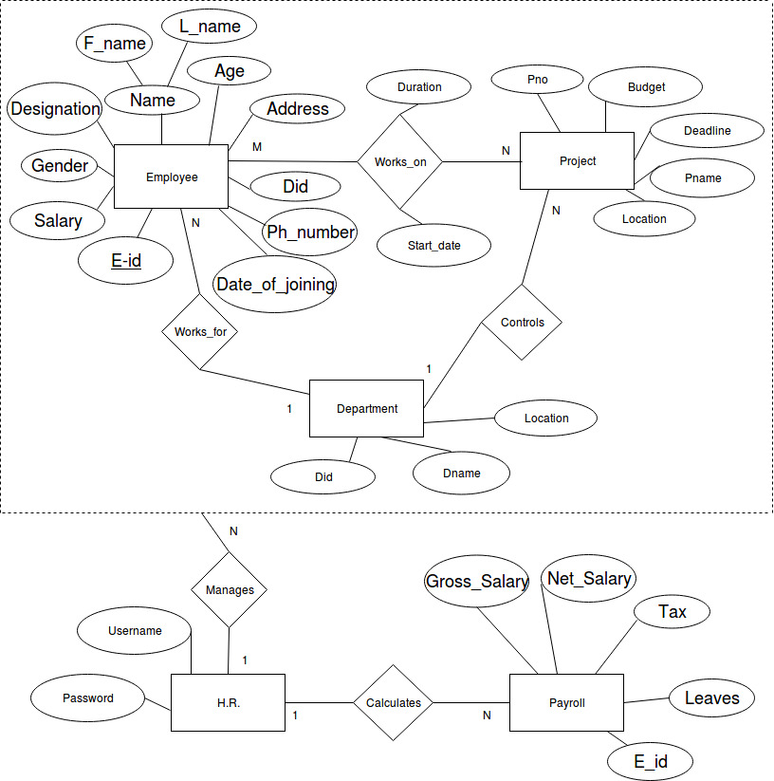

**DATA DICTIONARY:**

Employee(eid ,ename ,age ,salary ,gender ,address ,phone_no ,date_of_joining ,did ,designation)

Project(pno ,pname,budget,deadline ,location )

Department(did ,dname ,location )

Hr(username ,password )

Payroll(eid ,tax ,gross_salary ,net_salary ,leaves )

Works_on(eid ,pno ,duration ,start_date )

Controls(did ,pno )

*Fragments :*

Details about the various fragments and replicas in the schema.

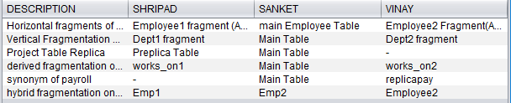

*Triggers :*

List of Insert and delete triggers on users to handle the problem of consistency of the table and its fragments upon insertion and deletion of data on table and also to handle updates on the table.

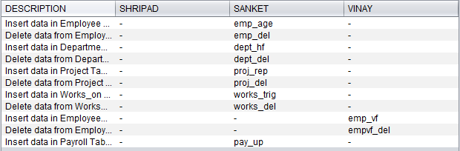

**QUERIES :**

1. *Projects under CMPN department:* Select p.pno,p.pname,p.pname,p.budget,p.location,p.budget from project p where pno IN (Select pno from controls where did=(Select did from department where dname='cmpn'));
2. *Employees with zero leaves:* Select * from employee where eid IN (Select eid from payroll where leaves=0);
3. *Projects under IT department with budget greater than 10000:* Select * from project where pno IN (Select pno from controls where did=(Select did from department where dname='it')) and budget > 10000;
4. *Employees from Chembur with salary > 50000 and designation not Manager:* Select * from employee where address IN ('chembur','Chembur') and salary > 50000 and designation NOT IN ('Manager','manager');
5. *All Manager:* Select * from employee where designation IN ('Manager','manager');

**CONCLUSION :**

The Database of this system can also easily be ported in any other standard database with nominal change. The manager of office used to spare lot of time even after the normal office hours to get the work done of maintaining record of employee's but after implementing above standalone application there is no need of such hectic task. Now the report can be easily prepared on project and project can be traced easily. Now by using our system, the administrator can easily generate payroll.

**REFERENCES / BIBILIOGRAPHY :**

Black Book on Basic NetBeans 2003 by Steven Holzner.

**WEBSITES :**

www.vbtutorials.com

www.logicatwork.com

www.oracle.com

**ENGINES :**

Yahoo,Google

